

**TTcoin White Paper 2022**

**www.ttcoin.info**

**FOREWORD**

**TTcoin, unlike many cryptocurrencies, turns its investments into real projects. Established companies and brands bear the name and logo of TTcoin. The payment method of these companies and brands is TTcoin.**

**TTcoin aims to combine all projects into one. It includes Web3, virtual worlds, payment systems, coins, tokens, airdrops. It aims to integrate all tasks in a single network and provide convenience to users.**

**Investments are protected and offered to the public. In this way, financial support is provided for TTcoin. Furthermore, users holding TC tokens will have a say in TTcoin, through the systems that are going to be set up in the future.**

**The current goal of the TTcoin team is to present the project to many users. Then, when all plans are finished, financial support will be provided to the stock markets and the team will work towards the target of $0.01.**

**It is planned to achieve these goals with several many projects between 2022 and 2024.**

**TTcoin team does not aggrieve their users nor steal their investment. TTcoin can be easily bought from many contracted exchanges.**

**TTcoin can be easily traded between users.**

***"Your investments are safe with TTcoin. More than just a cryptocurrency."***

**WHAT IS TTCOIN?**

**TTcoin was created on March 24, 2021, by Tayfun Taner and Tunahan Taner as a TRC-20 smart contract on the TRON network. In the first period, TTcoin entered a few months of intense work to conduct its projects, and in this process, they created their first two projects: the TTcoin mining application, and TTcoin Network. At the same time, it actively started the service of TTcoin ultimately. It was published on the Google Play store on June 16, 2021. Reaching 1 million users in a short time and reaching their goals one step further. TTcoin was listed on eight different exchanges in 3 months and increased its value by 400%. The record value increase of Ttcoin was documented as 1900%. The game has been created with many applications, including the TTcoin Rewards application, and was released on the Google Play store. In this way, TTCoin gave rewards to the users who performed the tasks in the applications. Advertising revenues provided financial gains to the projects.**

**TTcoin was created with the wolf cub logo icon. In the name of institutionalism, the TTcoin team later changed the logo to a logo containing the letters of TC.**



**TTcoin will be used as a currency in TC Token projects and applications. TTcoin is headquartered in Turkey and performs its actions the safest. TTcoin has been granted permission by the Ministry of Interior of Turkey to conduct many real projects for its purposes.**

**TTcoin works with the TRC20 and BEP20 networks. These two networks can be traded on exchanges.**

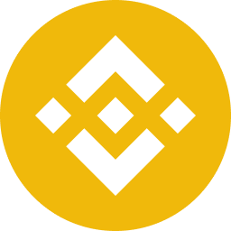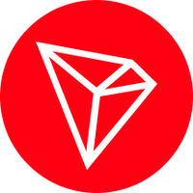

**BEP20 <-> TC <-> TRC20**

**WHAT IS THE PURPOSE OF TTCOIN?**

**TTcoin has made agreements with many genuine brands and institutions to add value to this investment while making the best use of the asset. These institutions and brands will carry the name of TTcoin and will even add more value to the investment.**

**In this way, it is ensured that the investment is fully protected by preventing manipulation events on the stock exchanges. Besides virtual projects, TTcoin also plans to act as an intermediary with various well-known brands and institutions by creating many real projects.**

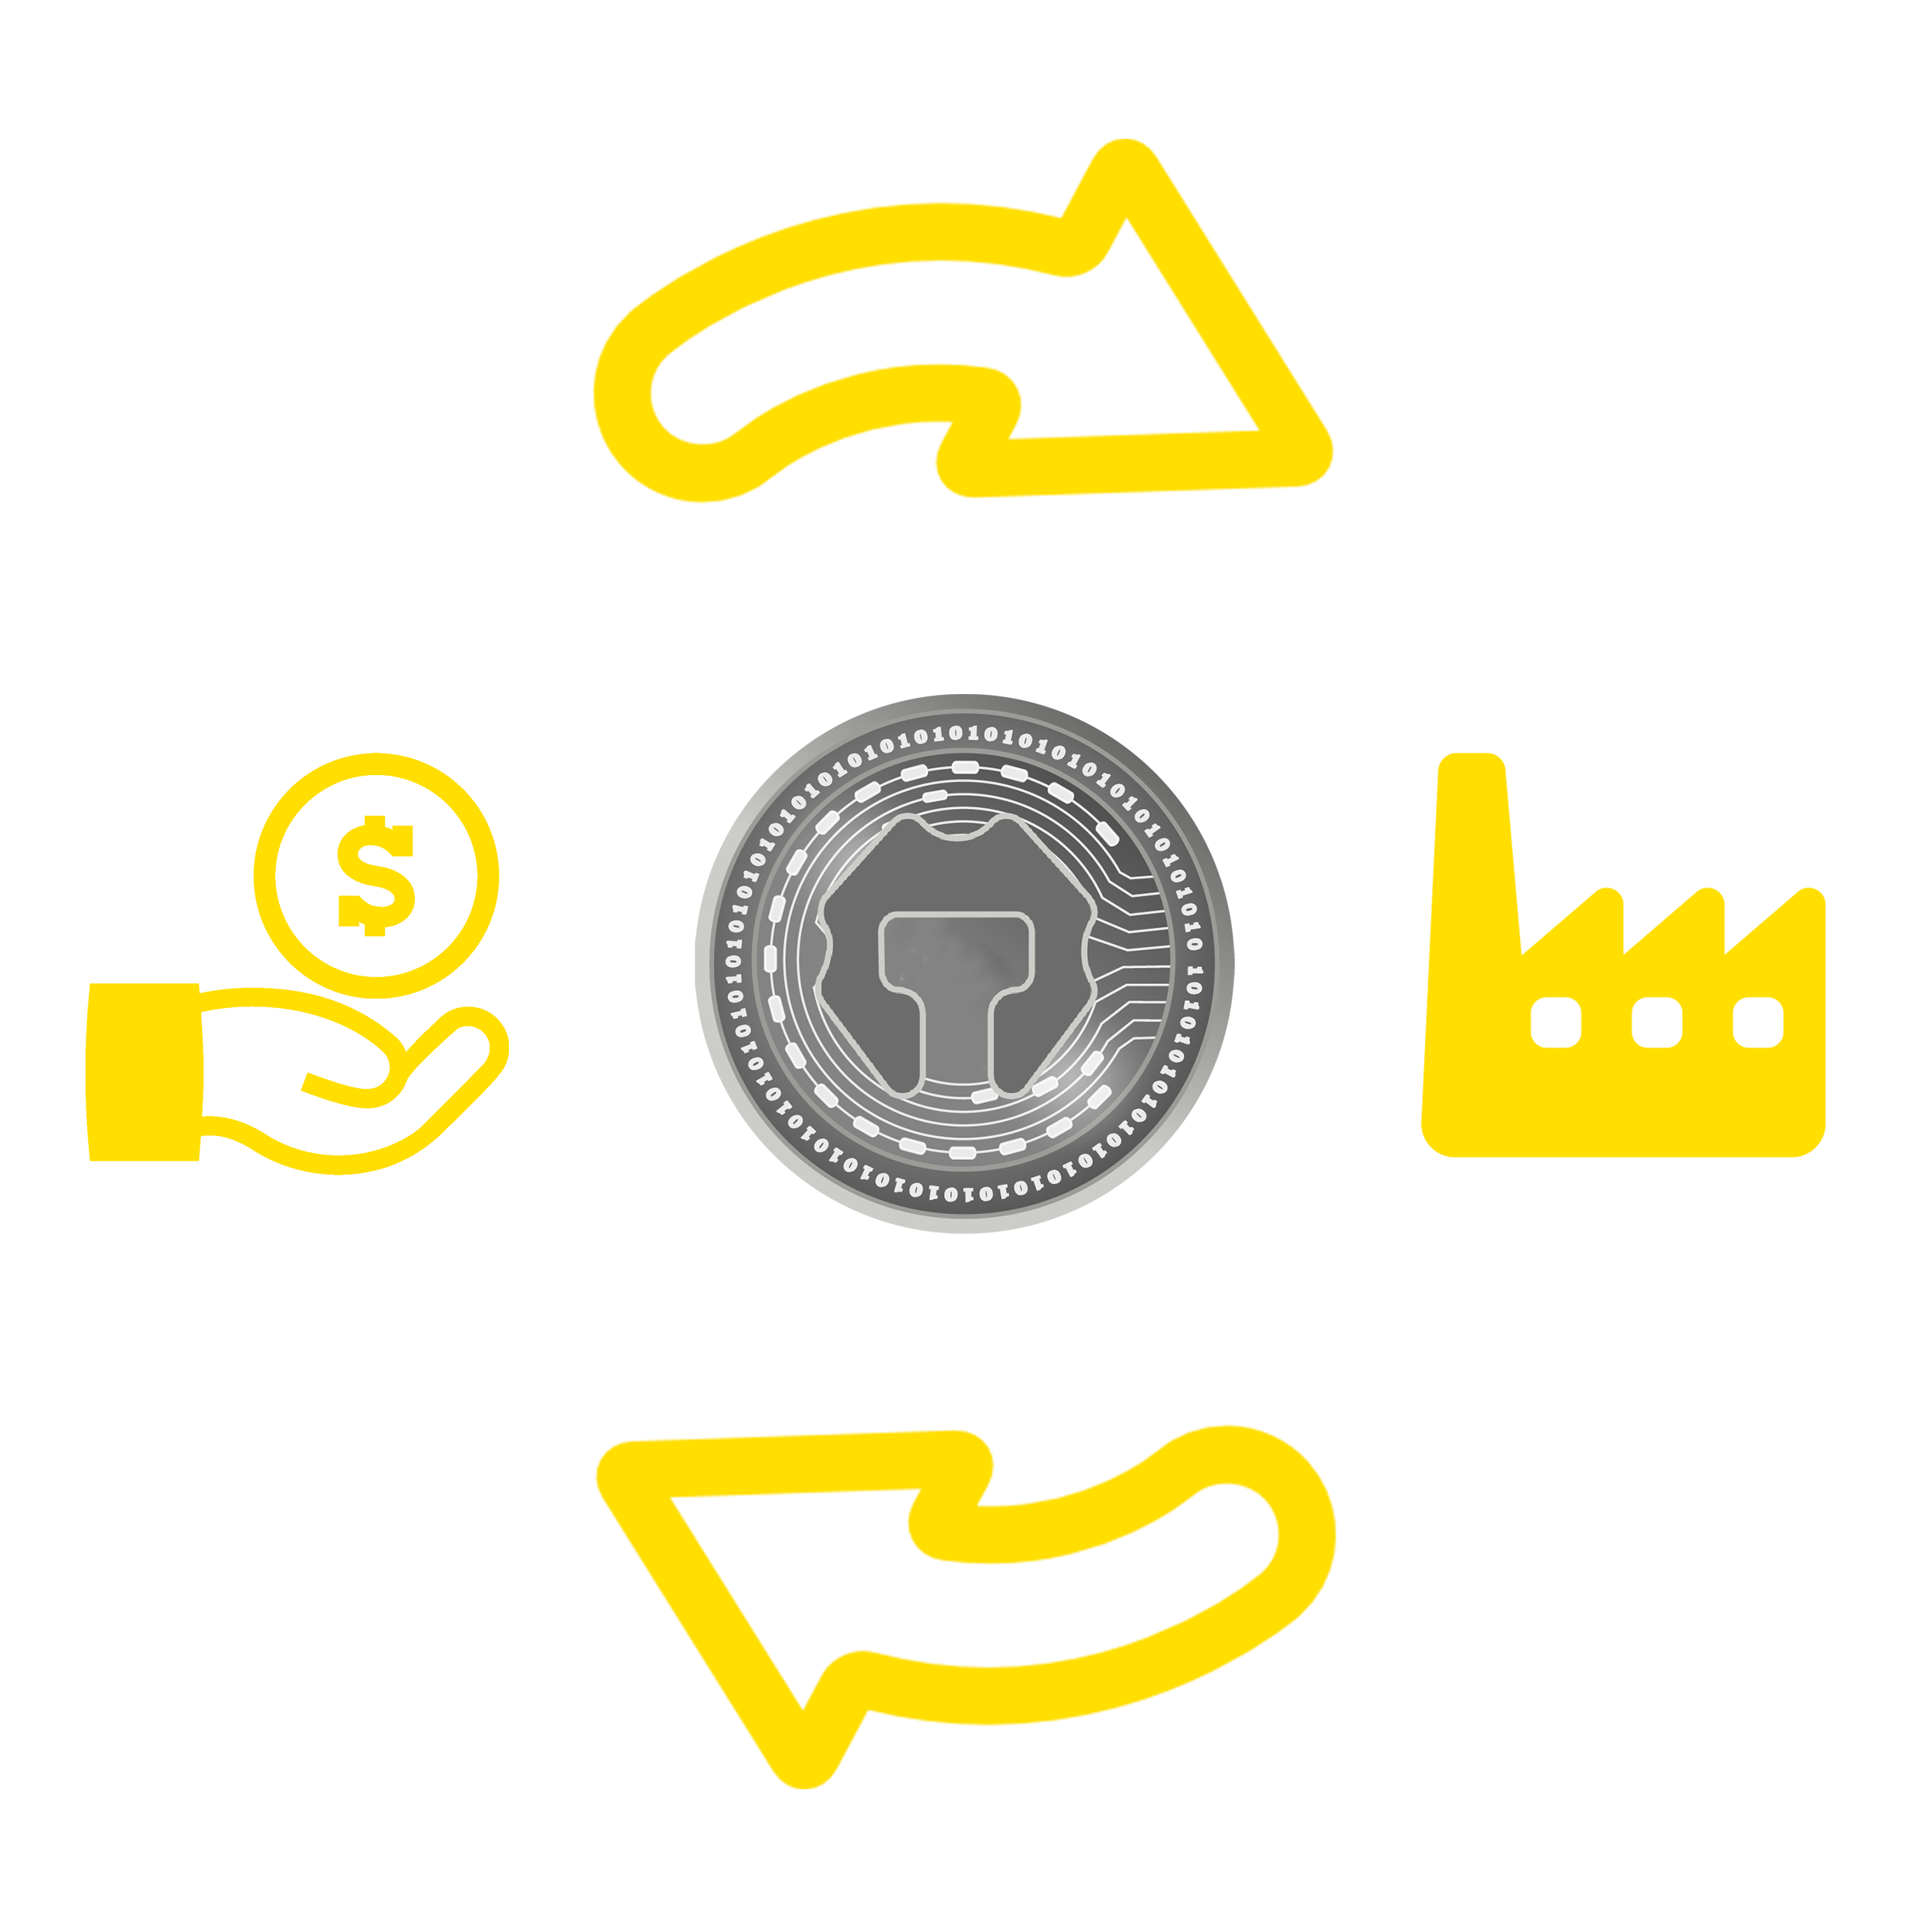

**TTcoin has signed agreements with many advertising agencies and generating revenue from mobile applications and games. This income is transferred to exchanges as a fund to serve TTcoin investors better while developing TTcoin projects. Apart from this, TTcoin mining is also ongoing and being done.**

**In this direction, we are working to develop the project no matter what happens without deviating from the path we are following. Improvements are being made slowly and surely to add value to our investors' rights, assets, and the time they have gave.**

**PLANNED TARGETS**

**Blockchain networks and the crypto market are developing day by day, and they can be seen in different areas. Unfortunately, the number of opposing teams and fake projects are increasing in virtual money and crypto, which is now an indispensable part of our lives.**

**TTcoin has made serious payments to keep its users away from such projects. It has prove itself in the crypto field, and provide confidence to users with real projects. Our goal is to provide a substructure that is built with conviction. Our goals are to carry out activities that will attract users and strengthen our audience with certain airdrop draws every month.**

**In order to protect TC Token from manipulative movements in the stock markets, the tokens in the market are burned at the end of the month. Our goal is to protect the TTcoin price range, with sudden drops and always moving up. We use our social media accounts actively in order to help our users.**

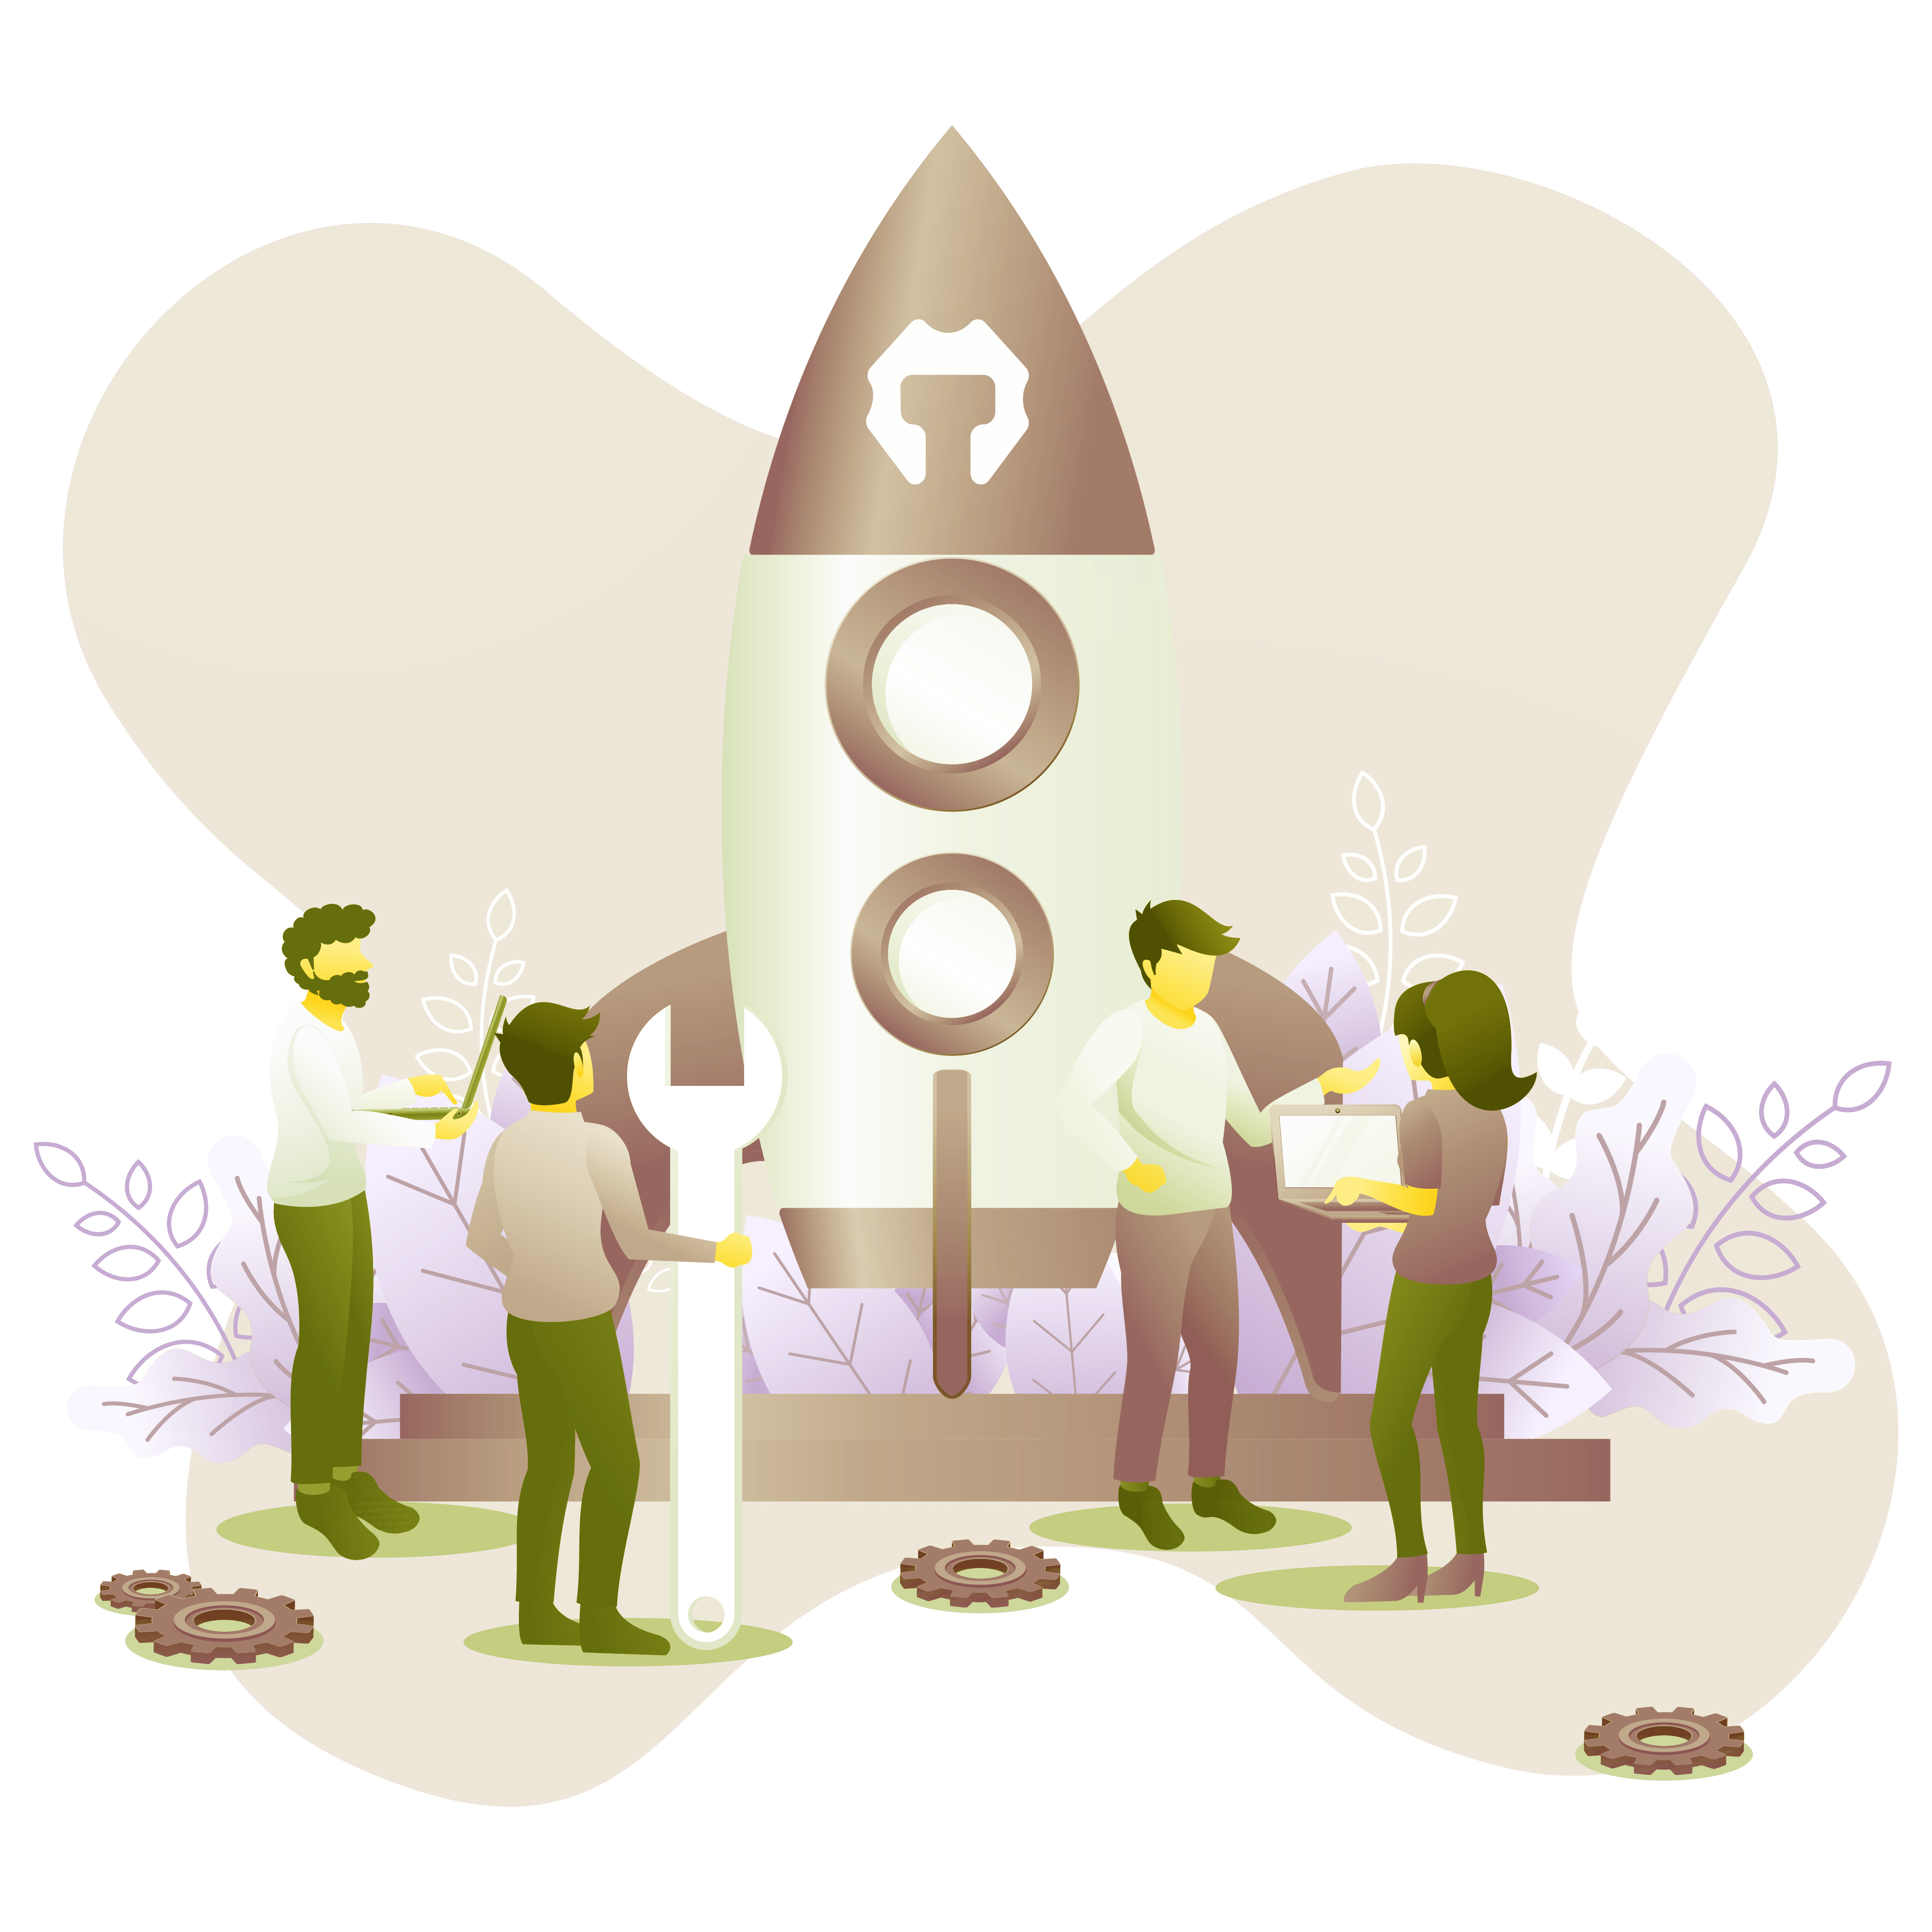

**PROJECTS**

**TTcoin works to protect investors' assets and guarantee that the project is potent and own infrastructure. In this way, the project will contribute to the community and develop its ecosystem without being dependent on anyone.**

**Except for many other virtual projects, the TTcoin team works for many tangible projects in real life. TTcoin will enable the purpose of using cryptocurrencies in different areas, hence presenting cryptocurrencies to future generations in a better way.**

**Plans are being made to ease states to accept TTcoin projects in their countries. The first cryptocurrency football club (TTcoin FC) was also set up in this direction.**

**TTCOIN FOOTBALL CLUB**

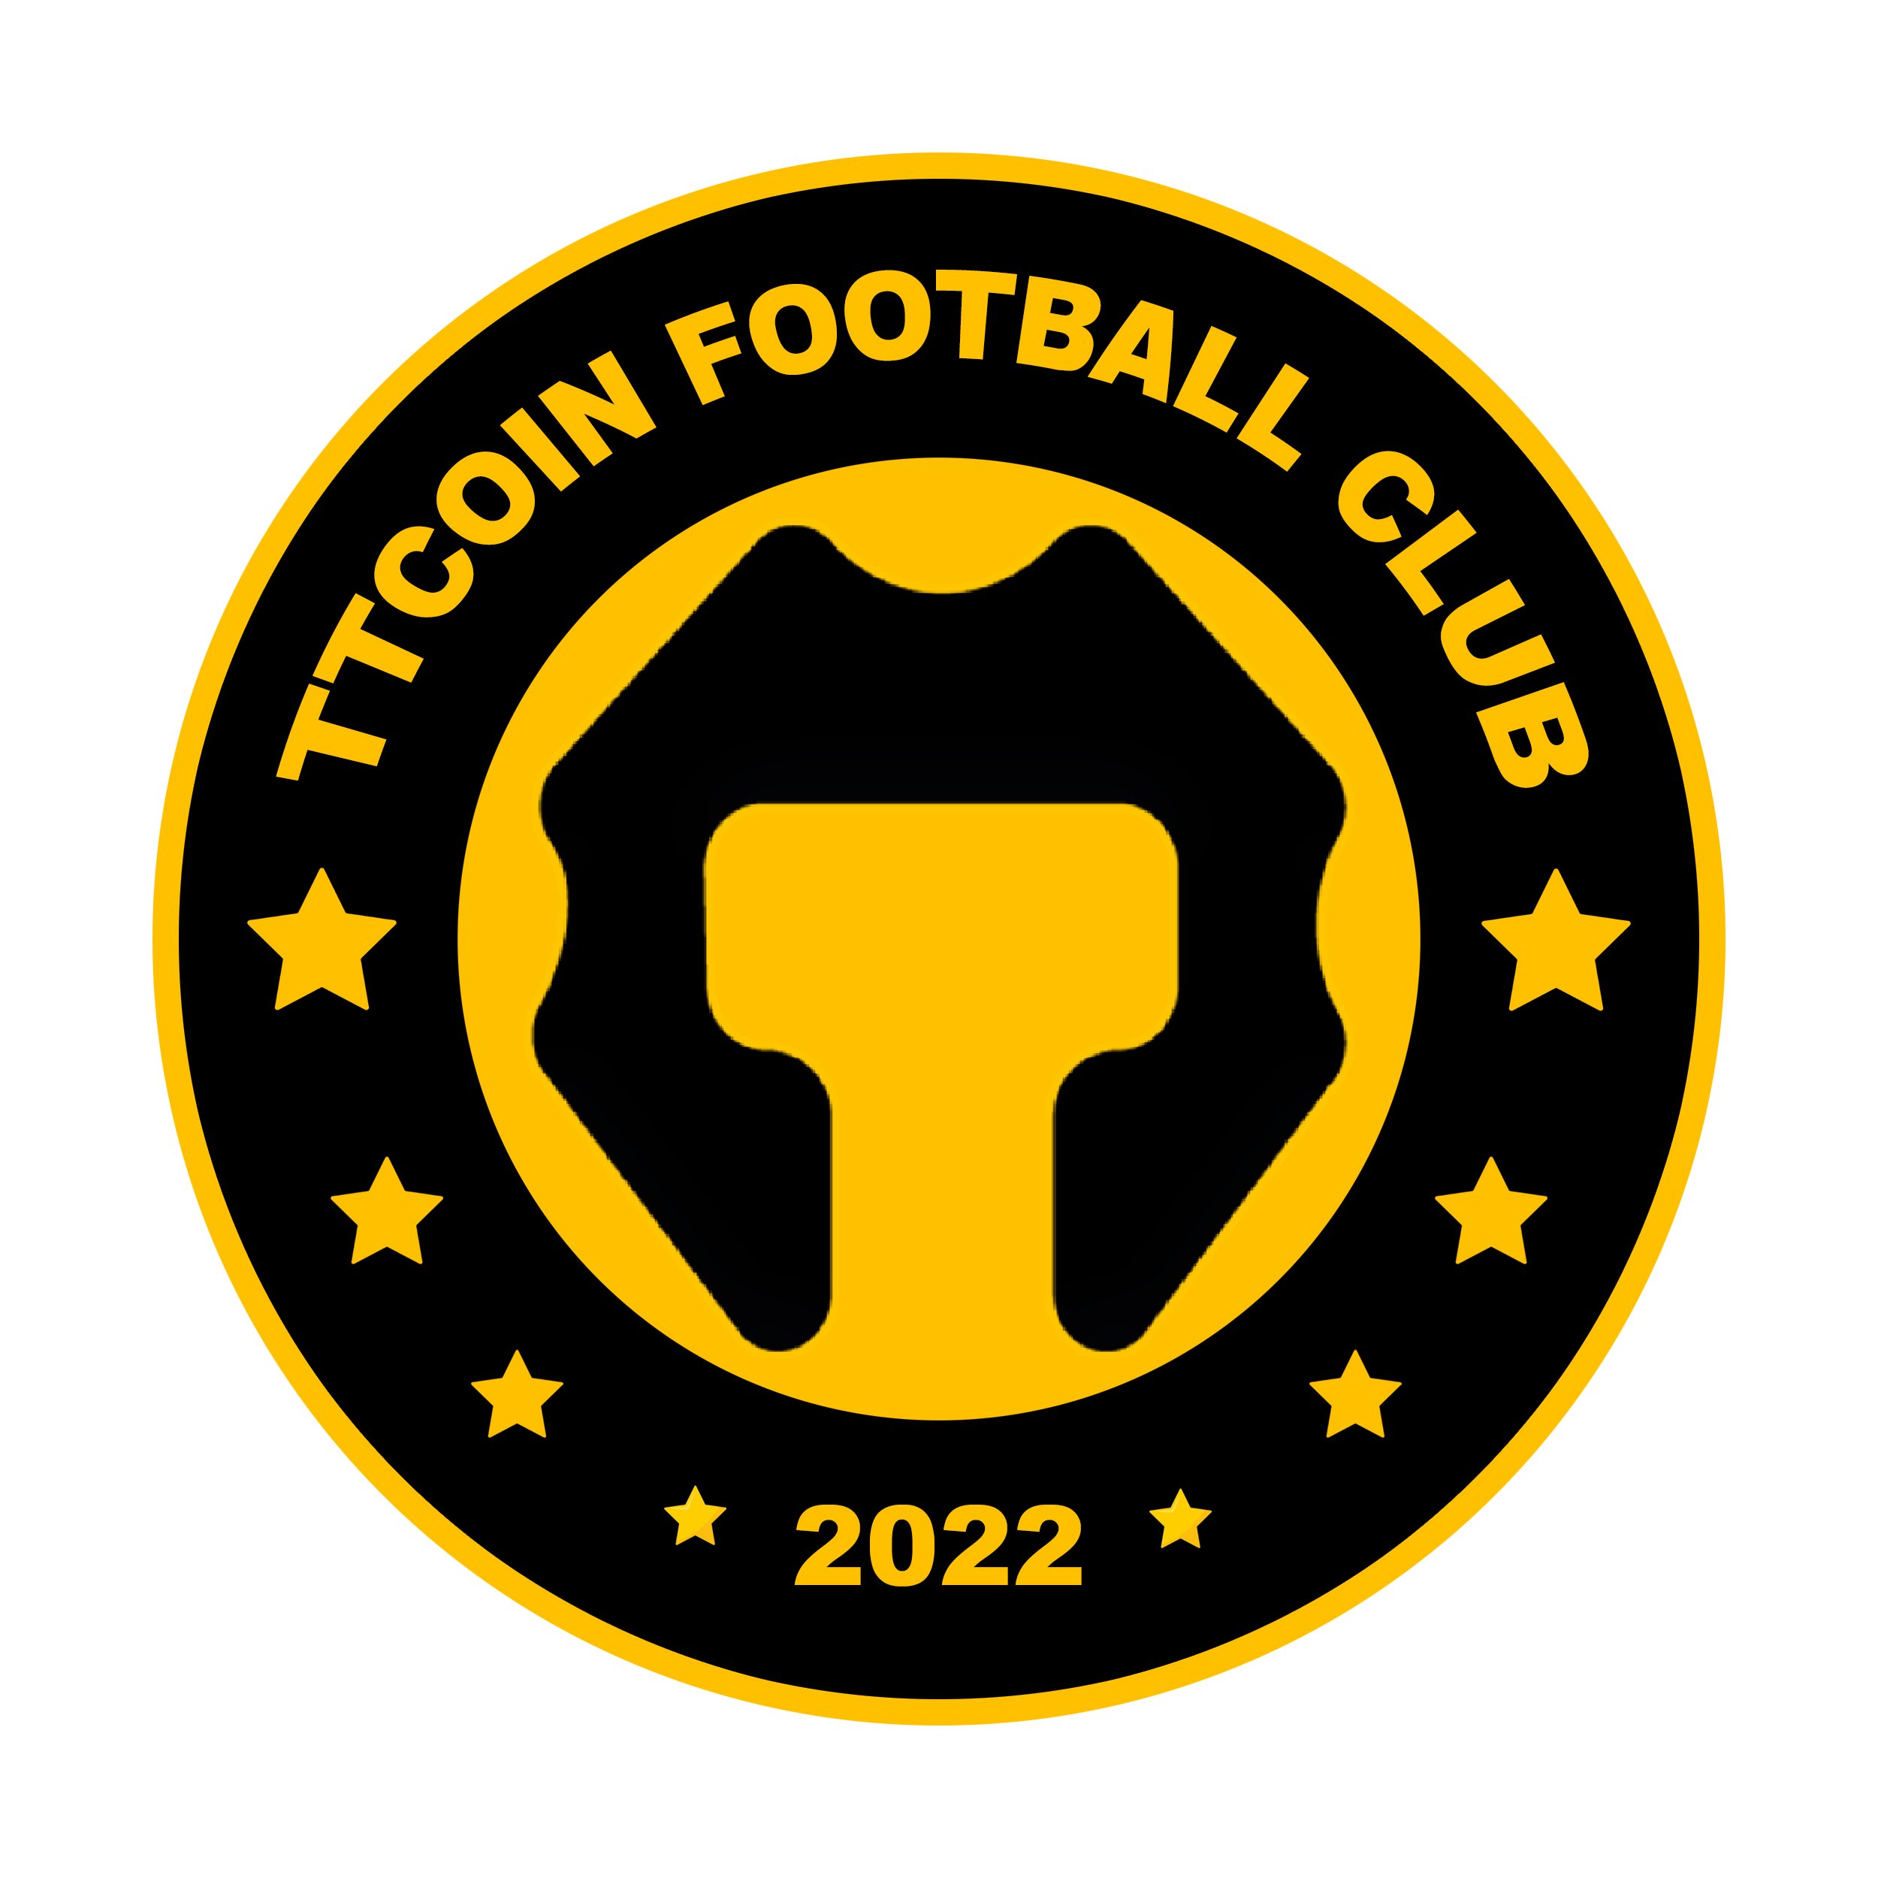

**The first cryptocurrency formation in the world is a football club. According to all the club activities, TC is an actual project to be burned.**

**With the TTcoin project, which will bring football and crypto together, investors will see the results of their investments.**

**www.ttcoinfc.com**

**TTcoin Football Club Token Burning Plan**

**TTcoin Football Club will burn 150 TC for each match played, 100 for each goal scored, 200 for each match victory, and 50 TC for each game that ends in a draw. In a championship, 500,000 TC Tokens will be burned to be taken from the exchange.**

**This amount will be calculated and burned each month.**

**TTCOIN WALLET**



**It is a decentralized cryptocurrency wallet that includes TTcoin and many other cryptocurrencies. Fees are charged as TTcoin for the transactions.**

**TCBIT EXCHANGE**

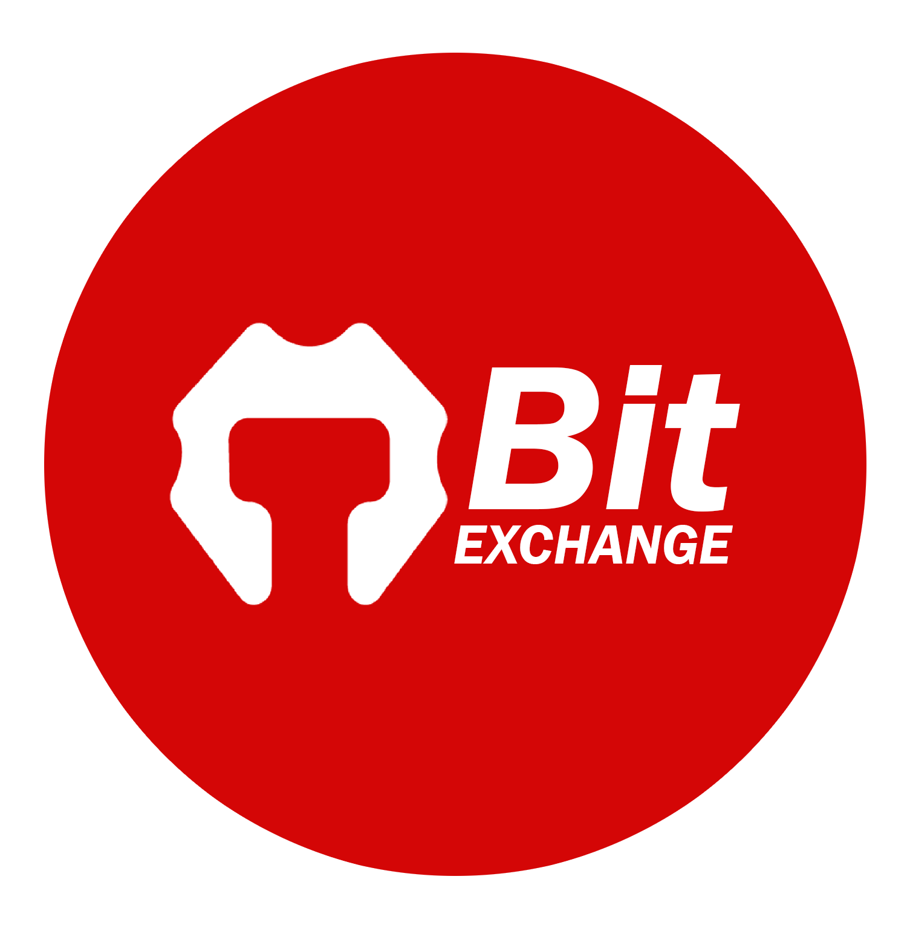

**It is a cryptocurrency exchange where many cryptocurrencies are traded and the cheapest fees.**

**Trading is done with TC Token pairs. It can be done with a token listing application if you have the proper cryptocurrency.**

**TCSHOP**

**TCShop is an e-commerce system where sales such as electronics, clothing, food, TTCOIN FC Licensed products bearing the TTcoin brand name.**

**TTSCAN (TC20)**



**It is an ecosystem that allows you to create TC20 tokens within the scope of smart contracts that it has in its structure with the shared network of TTcoin's networks are united. You can send these created tokens with a minimum network fee.**

**TTCOIN CHARITY**

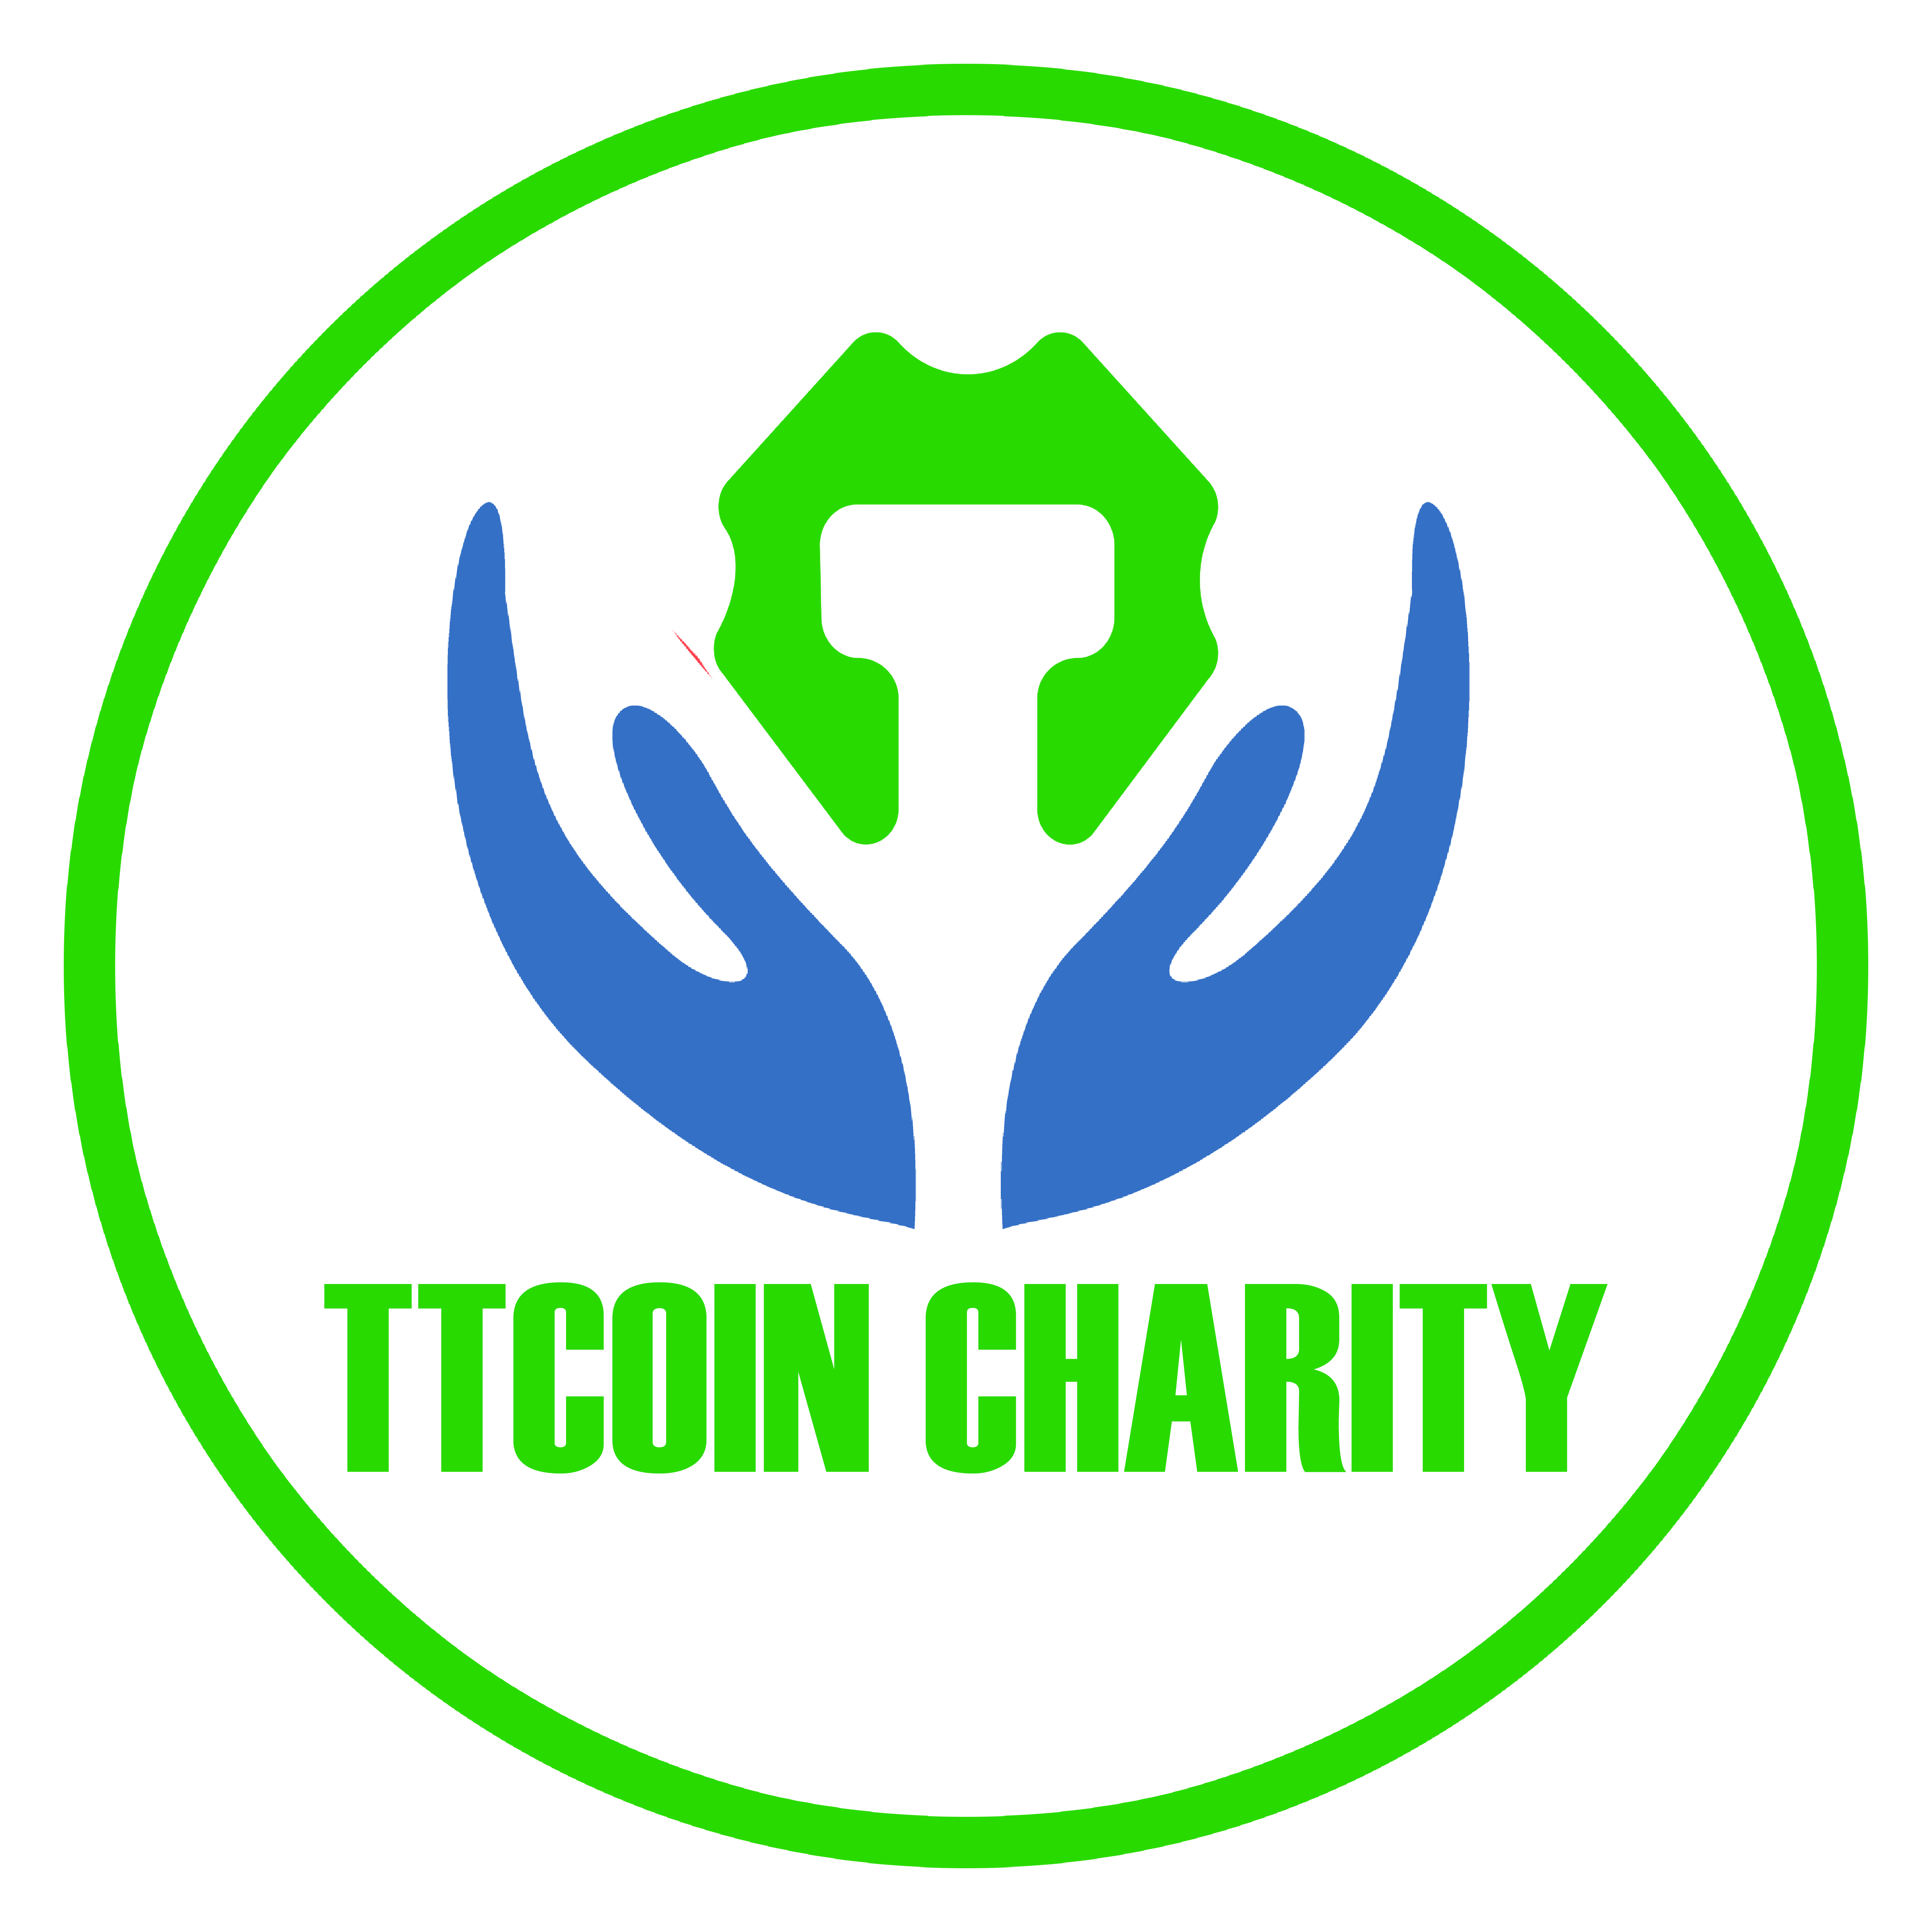

**It will serve as a charity organization that will perform in natural disasters, humanitarian aid, and many fields.**

**Most donations and transactions to be made in TTcoin will depend on the amount earned from the fees. TTcoin Charity Organization will aid in forestation, natural disasters, and many other areas.**

**ON WHICH NETWORKS DOES TTCOIN EXIST?**

**TTcoin is working to be available on many networks. The amount created in these networks is produced by burning in another web, and the supply is kept stable.**

**You can follow price and supply on cryptocurrency data listing sites. Reliable supply and circulation are available on our website in their most straightforward form.**

[**CoinMarketCap**](https://coinmarketcap.com/currencies/ttcoin/) **–** [**CoinGecko**](https://coingecko.com/en/coins/ttcoin) **-** [**CoinCodex**](https://coincodex.com/crypto/ttcoin/)

**TRC20 Smart Contract**

**It was the first release network on March 24, and there are now more than two billion burned tokens in this network.**

**Extremely high network fees are charged, which is why most investors use the BEP20 network.**

**Token Address:** [**https://tronscan.org/#/token20/TCMwzYUUCxLkTNpXjkYSBgXgqXwt7KJ82y**](https://tronscan.org/#/token20/TCMwzYUUCxLkTNpXjkYSBgXgqXwt7KJ82y)

**BEP20 Smart Contract**

**On December 23, the TTcoin team switched the TRC20 network to the BEP20 network due to the excessive network fees and disruption in the payments to miners. It is currently actively collecting its investors in this network.**

**Token Address:** [**https://bscscan.com/token/0x659049786cB66E4486b8C0E0cCC90a5929a21162**](https://bscscan.com/token/0x659049786cB66E4486b8C0E0cCC90a5929a21162)

**Token Information**

**Name: TTcoin**

**Symbol: TC**

**Decimal: 4**

**Max Supply: 6,000,000,000**

**Official Web Site:** [**www.ttcoin.info**](http://www.ttcoin.info)

**API TOTAL SUPPLY:** [**https://api.ttscan.net/api.php?q=totalcoins**](https://api.ttscan.net/api.php?q=totalcoins)

**API CIRCULATING SUPPLY:** [**https://api.ttscan.net/api.php?q=circulating**](https://api.ttscan.net/api.php?q=circulating)

**TTCOIN TOKENOMICS**

**TTcoin economy; planned as in the chart below. The burning process will be carried out according to the number of the allocated amount. It is targeted to burn two billion. The burning will continue even if the goal is reached.**

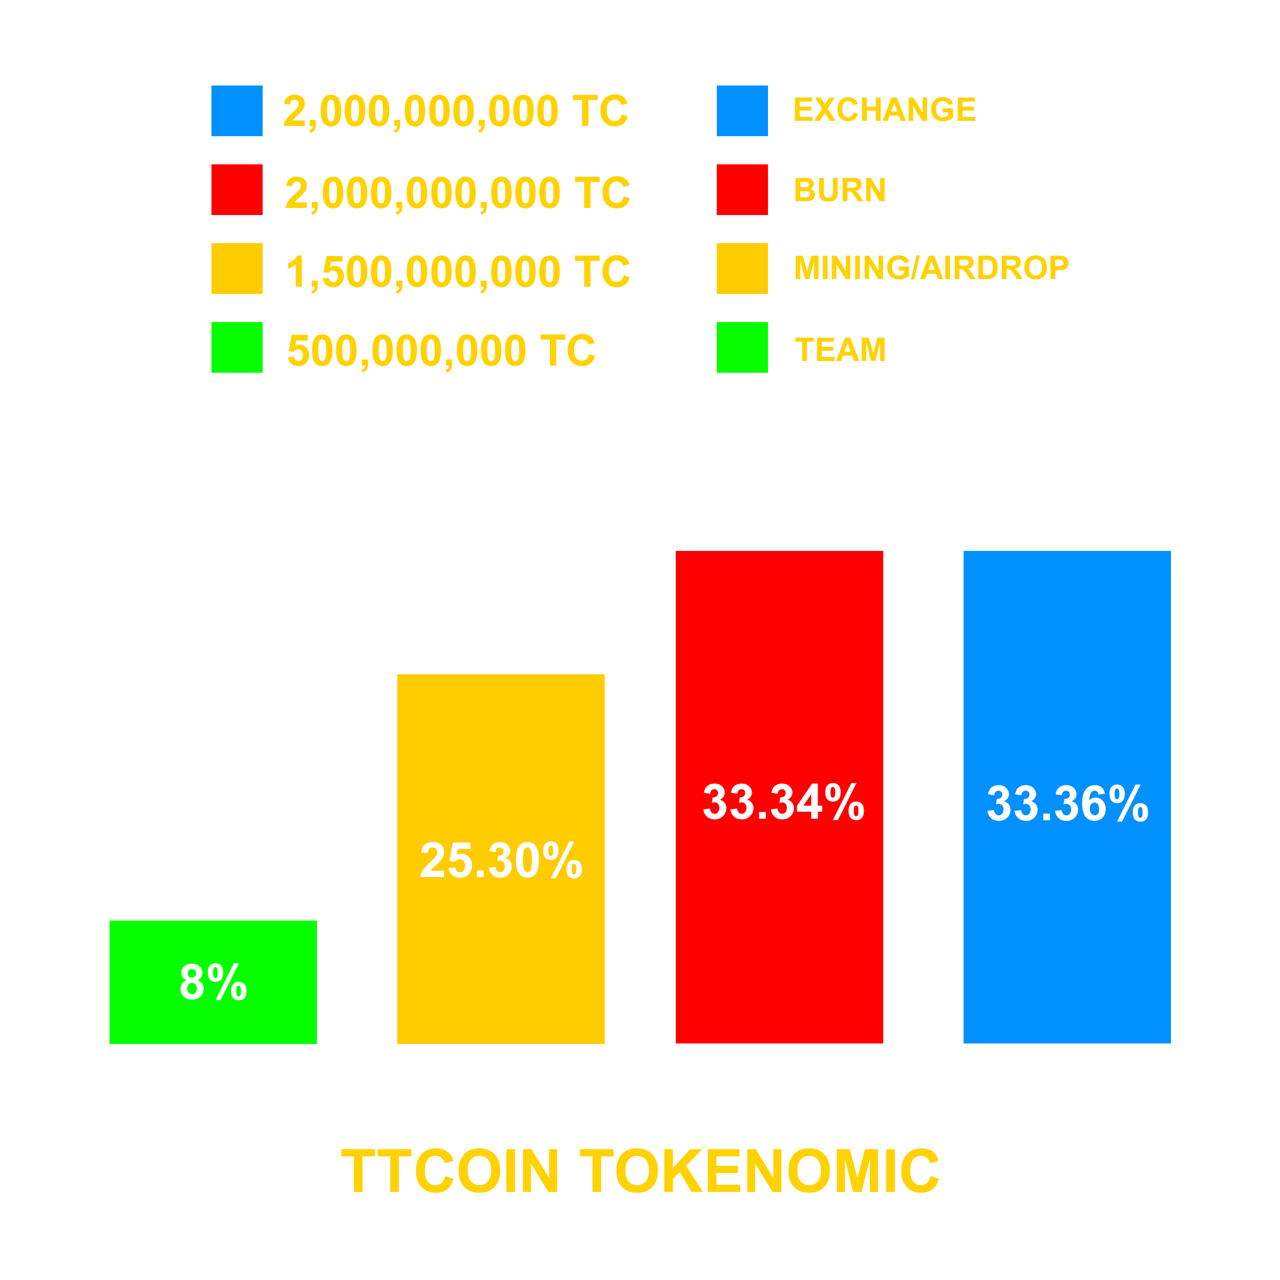

**Two billion is allocated to the exchanges. Since TTcoin will make at least one exchange agreement in each country, this amount will be sufficient. In addition, users can also send mining earnings to exchanges by users. So it has been tried to keep the circulating amount low.**

**TC TRC20 Burning Address: [TWgKYLfaFmR3h433LwDb9mVymtmPTo67PN](https://tronscan.org/" \l "/contract/TWgKYLfaFmR3h433LwDb9mVymtmPTo67PN/code)**

**Team Wallet:** [**TPTH1snA5eqsCsVLCjf3xC4dbWDU1PhRqp**](https://tronscan.org/#/address/TPTH1snA5eqsCsVLCjf3xC4dbWDU1PhRqp)

**TTCOIN BURNINGS**

**TTcoin's burning roadmap is formed by burning the amount determined as a result of the user's activities in the TTcoin application and real projects. These processes are as follows:**

1. **TTcoin Network Fee Burning**

**10% of the withdrawn amount in the TTcoin Network application is reduced from the withdrawn amount and burned.**

1. **TTcoin Rewards Fee Burning**

**500 TC is deducted from the withdrawn TTcoin amount. This quantity is collected in a pool at the end of the month and burned.**

1. **TTcoin Football Burning**

**TTcoin Football Club, one of the TTcoin projects, makes burns in the amount determined due to all its activities. This quantity is gathered from the exchange and burned. TTcoin team shared details under the title of “TTCOIN FOOTBALL CLUB.”**

1. **TTcoin Team Burning**

**These are the burnings made by the TTcoin Team. On specific dates, burnings are made up to the quantity collected from the exchanges.**

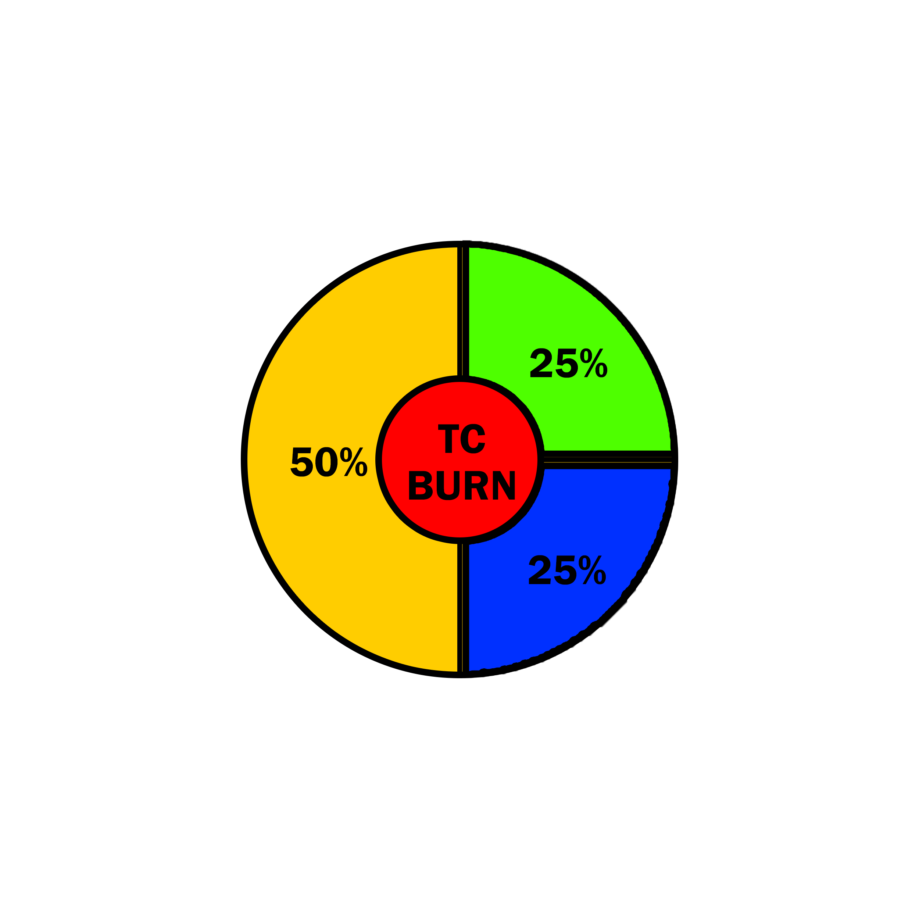

**IN WHICH WALLETS CAN YOU ADD TTCOIN?**

**TTcoin can be easily added to any active cold or exchange wallet available in the market. You can easily add TRC20 and BEP20 smart contracts to applications with the contract address or search for the TTcoin name. You can do transactions in these wallets.**

**You can store your TTcoins in the two most used wallets.**

1. **TRUST WALLET**

**You can add it by searching for the name of TTcoin in the Trust Wallet app. If it does not appear in the search result, you can add it to your wallet with the "Add Private Token" option.**

**Compatible with TRC20 and BEP20 networks.**

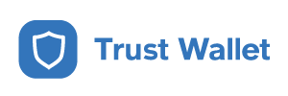

1. **TRONLINK PRO WALLET**

**With the Tronlink Pro application, which is only compatible with the TRC20 network, you can buy TTcoin from the SunSwap site and store your TTcoins in this wallet.**



**ALTERNATIVE WALLETS**

**SAFEPAL, COINS, imTOKEN, TokenPocket**

**MOBILE APPS**

**In our apps, you can mine TTcoin, earn rewards and learn about TTcoin.**

1. **TTcoin Network**

**It was published on the Google Play store for TTcoin mining on June 16. In a short time, it reached two million active miners. On December 21, the TTcoin team terminated mining activities.**

**Link:** [**https://play.google.com/store/apps/details?id=com.ttcoin.tc**](https://play.google.com/store/apps/details?id=com.ttcoin.tc)



1. **TTcoin Rewards**

**It is an application that can earn TTcoin by doing specific tasks. You can earn TTcoin by spinning the wheel and playing games. You can even earn daily prizes!**

**Link:** [**https://play.google.com/store/apps/details?id=com.app.ttcoin**](https://play.google.com/store/apps/details?id=com.app.ttcoin)

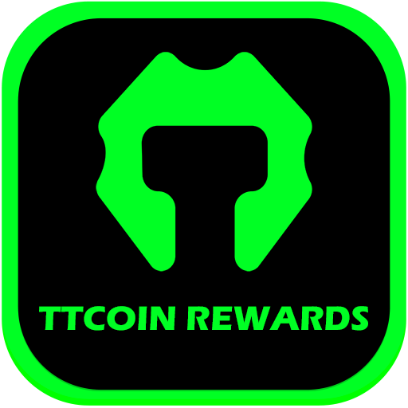

1. **TTcoin Info:**

**It is an application where you can access information about TTcoin and receive instant notifications.**

**Link:** [**https://play.google.com/store/apps/details?id=ttcoin.info**](https://play.google.com/store/apps/details?id=ttcoin.info)

**MEANING OF THE LOGO**

**The monetary symbol of TTcoin is TC. Its logo includes the letters T and C. The letter T comes from the founders' name, and the letter C comes from the initials of the word coin.**

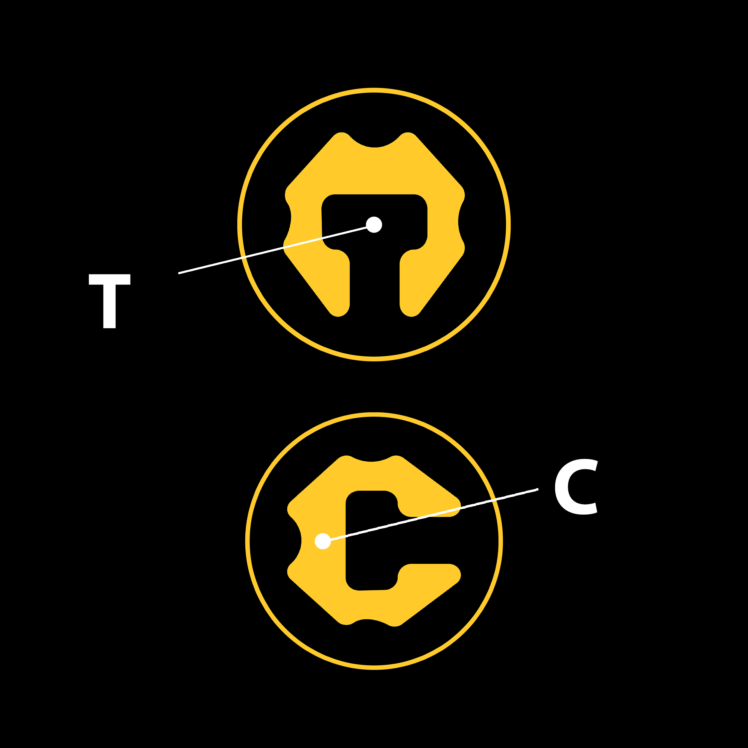

**TTCOIN TEAM**

**Unlike other projects, TTcoin follows a path and is superior to other projects in this context. The TTcoin team funds the project. It makes preliminary agreements with exchanges and obtains many trust certificates. The TTcoin team is not responsible for the TC Token other than the amount of TTcoin allocated. The TTcoin team creates the website and roadmap information. Users and investors control all systems outside of this process.**

**What are the Responsibilities of the TTcoin Team?**

**The TTcoin team develops projects and provides investors with an environment of trust. They implement marketing strategies for TTcoin and make deals with new exchanges.**

**The TTcoin team manages websites, social media, and many projects.**

**There is no manipulation in the stock markets, and an open market is created. A certain amount of TTcoin is burned by the team every month.**

**TEAM:** [**https://www.ttcoin.info/team**](https://www.ttcoin.info/team)

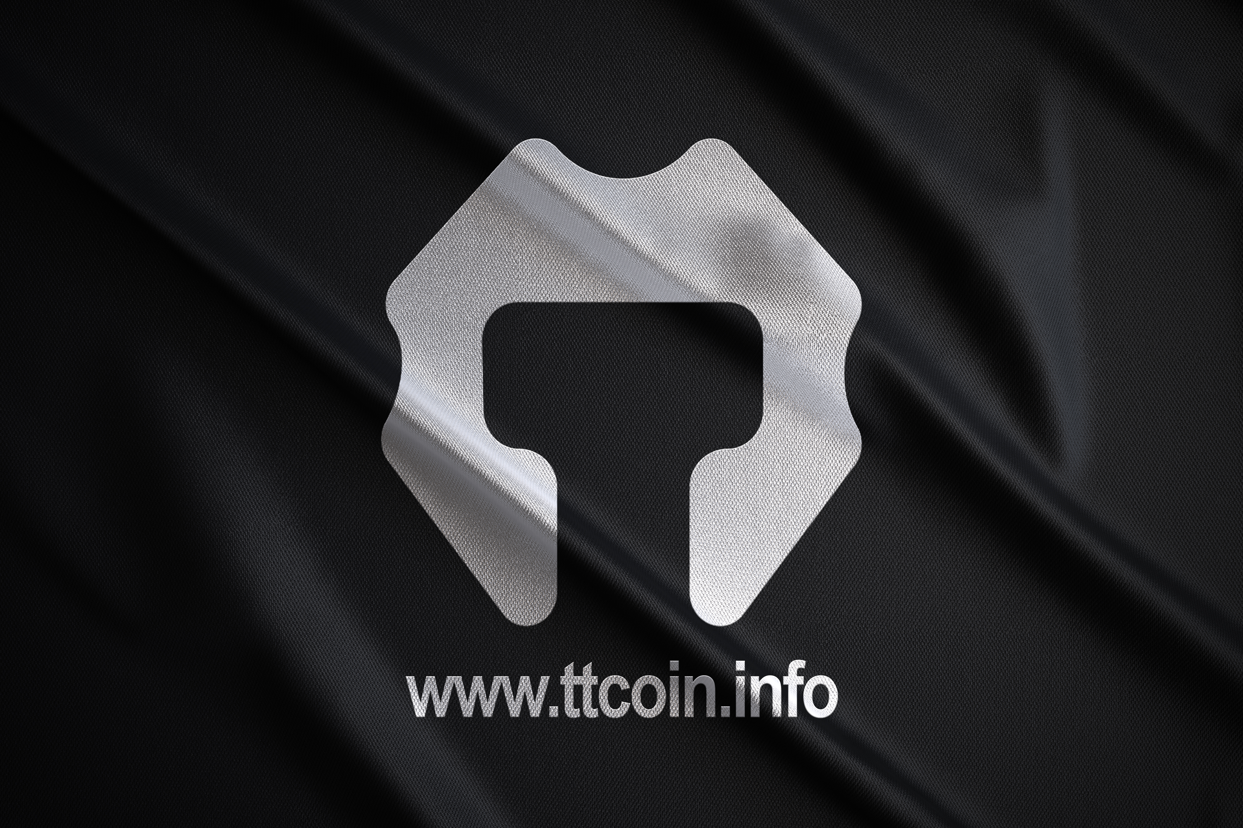

**How Much TTcoin is Allocated to Our Team?**

**The amount allocated to the TTcoin team is 500 million coins. With the BEP20 network and ERC20 network fork, this amount will never change. Projects are carried out with this quantity. With new crypto exchange agreements, some amount is transferred to these exchanges. Exchanges can use it for airdrop rewards. Ensuring the continuity of the projects shows that the team members have a say on TTcoin.**

**Who are TTcoin Delegates, and What Are Their Duties?**

**Delegates represent TTcoin in their country of residence. As part of the community, their task is to assist users on social networks in their native language.**

**Their mission is to promote the development of TTcoin in their community, listen to other people's ideas, and relay problems to us.**

**They earn a certain amount of TTcoin when they do the given tasks.**

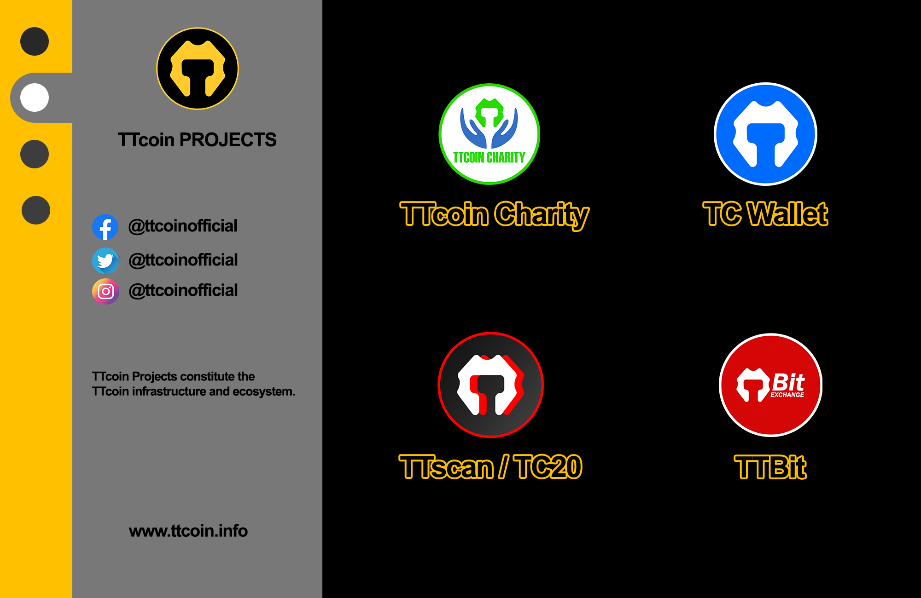

**OFFICIAL LINKS**

**Web Site:** [**https://ttcoin.info**](https://ttcoin.info)

**Whitepaper:** [**https://ttscan.net/wp/whitepaper.pdf**](https://ttscan.net/wp/whitepaper.pdf)

**Logo:** [**https://ttscan.net/logo/**](https://ttscan.net/logo/)

**Total Supply API:** [**https://api.ttscan.net/api.php?q=totalcoins**](https://api.ttscan.net/api.php?q=totalcoins)

**Circulating Supply API:** [**https://api.ttscan.net/api.php?q=circulating**](https://api.ttscan.net/api.php?q=circulating)

**CoinMarketCap:** [**https://coinmarketcap.com/currencies/ttcoin/**](https://coinmarketcap.com/currencies/ttcoin/)

**CoinGecko:** [**https://coingecko.com/en/coins/ttcoin**](https://coingecko.com/en/coins/ttcoin)

**BEP20 TC Address:** [**https://bscscan.com/token/0x659049786cB66E4486b8C0E0cCC90a5929a21162**](https://bscscan.com/token/0x659049786cB66E4486b8C0E0cCC90a5929a21162)

**TRC20 TC Address:** [**https://tronscan.org/#/token20/TCMwzYUUCxLkTNpXjkYSBgXgqXwt7KJ82y**](https://tronscan.org/#/token20/TCMwzYUUCxLkTNpXjkYSBgXgqXwt7KJ82y)

**SOCIAL MEDIA**

**Twitter:** [**https://twitter.com/ttcoinofficial**](https://twitter.com/ttcoinofficial)

**Facebook:** [**https://facebook.com/ttcoinofficial**](https://facebook.com/ttcoinofficial)

**Instagram:** [**https://instagram.com/ttcoinofficial**](https://instagram.com/ttcoinofficial)

**Linkedin:** [**http://linkedin.com/company/ttcoinofficial**](http://linkedin.com/company/ttcoinofficial)

**Youtube:** [**https://www.youtube.com/channel/UCw4ctJY-VD12hwHuHl1D9kw**](https://www.youtube.com/channel/UCw4ctJY-VD12hwHuHl1D9kw)

**Github:** [**https://github.com/TTCOIN-TC/**](https://github.com/TTCOIN-TC/)

**Google Play:** [**https://play.google.com/store/apps/details?id=com.ttcoin.tc**](https://play.google.com/store/apps/details?id=com.ttcoin.tc)

**Telegram Global:** [**https://t.me/ttcoinworld**](https://t.me/ttcoinworld)

**Telegram Channel:** [**https://t.me/ttcoinofficial**](https://t.me/ttcoinofficial)

**Telegram EN:** [**https://t.me/ttcoinenglish**](https://t.me/ttcoinenglish)

**Telegram TR:** [**https://t.me/ttcointurkey**](https://t.me/ttcointurkey)

**Telegram ID:** [**https://t.me/ttcoinindonesia**](https://t.me/ttcoinindonesia)

**Telegram PK:** [**https://t.me/ttcoinpakistan**](https://t.me/ttcoinpakistan)

**Telegram IN:** [**https://t.me/ttcoinindia**](https://t.me/ttcoinindia)

**Telegram KR:** [**https://t.me/ttcoinkorea**](https://t.me/ttcoinkorea)

**Telegram VN:** [**https://t.me/ttcoinvietnamese**](https://t.me/ttcoinvietnamese)